Shoe Shopping Spreadsheet with Instructions
- Use the Internet to research five (5) pairs of shoes that are of the same variety such as running shoes, dress shoes, boots, sandals, or sneakers. Each shoe must be found at a different online store.
- Open a new MS Excel document and name it “Shoe Shopping Spreadsheet”. Save to your H: drive.
- Open a new MSWord document and name it “Shoe Shopping Instructions”. Save to your H: drive.
- Type out all instructional steps to recreate the spreadsheet and chart. Use complete sentences in each step.
- Create an appropriate title for your new spreadsheet table.
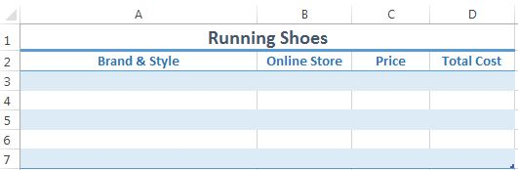
- Set up four columns for the following data: brand & style, online store, shoe price, and total cost (include sales tax).
- The fourth column will represent the total cost which includes 8.25% sales tax. Use the following formula to calculate the total cost.
=Price * 1.0825
- Format the spreadsheet for fill color, font color, borders and number format and font boldness, etc. You may add more formatting changes as you determine appropriate.
- Create a graph or chart of your choice representing the data. Chart should include chart title and axis titles.
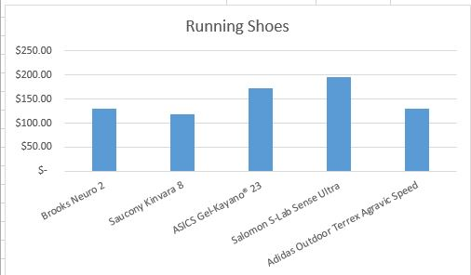
- Use the Windows Snipping Tool to show images or table data on your instruction sheet.
- Insert footer on both documents with name, date, class period.
- Print your instruction sheet and solution file to turn in for project grade.

Score Sheet for Project
Written Instructions (35 points)
Proper grammar and spelling. Complete sentences and well written instructions. Includes a picture of spreadsheet. Instructions must match spreadsheet.

Required Content in Spreadsheet (25 points)
Appropriate title, the name brand, location of the shoes, and original cost of the shoes and final price shown for all five shoes. Chart clearly represents the data in your table.

Formatting the Table and Chart (25 points)
Spreadsheet shows fill color, font color, borders and number format and font boldness. Chart includes chart title and axis titles.

Creativity (15 points)
Text alignment, text color, borders & number format and chart looks neat and professional.

